**ODIN II**

**TEST PLAN**

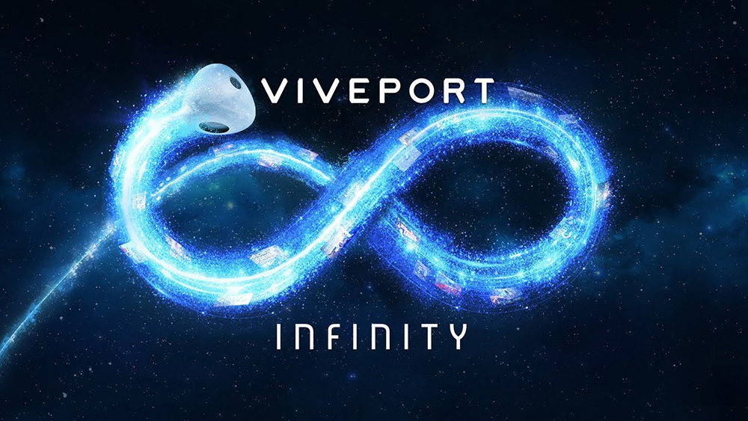

TEAM 11

TODD TOWNSEND, ABRAM FOUTS, KARLA BARRAZA LOPEZ, WENHAO CHENG, XUENING JIA

Sponsor: Brad Smith - Intel Corporation

Advisor: Fu Li

|  |  |  |
| --- | --- | --- |
| **Engine** | **Test** | **Result** |
| **Unity** | **Verify gaze vector variables in SteamVR API** | **complete** |
| **Unity** | **Verify gaze vector variables linking in API script** | **complete** |
| **SteamVR** | **Verify variable gaze vector variable types** | **complete** |
| **SteamVR** | **Verify field of view variable types** | **complete** |
| **Tobii** | **Verify gaze vector connection from SteamVR API** | **complete** |
| **Unity** | **Verify field of view variable in SteamVR API** | **complete** |
| **Unity** | **Verify compilation of gaze vector stand alone script** | **complete** |
| **Unity** | **Verify compilation of field of view stand alone script** | **complete** |
| **Unity** | **Verify connection between field of view default modifications** | **complete** |
| **Unity** | **Verify connection between gaze vector default modifications** | **complete** |
| **Unity** | **Verify compilation of touch controller stand alone script** | **complete** |
| **Unity** | **Verify variable assignments for touch controllers** | **complete** |
| **SteamVR** | **Verify variable assignments for touch controllers** | **complete** |
| **Unity** | **Verify touch controller API Hook** | **complete** |
| **Unity** | **Verify gaze vector API Hook** | **complete** |
| **Engine** | **Test** | **Result** |
| **Unity** | **Verify field of view API Hook** | **incomplete** |